**Exercise 4(1): Creating a Website using HTML and CSS**

You have been asked to create the EasyMake Recipe website. The diagram below shows the **navigational structure** of the site.

|  |  |  |  |  |
| --- | --- | --- | --- | --- |
| BBC website  *(external link)* |  | Home Page with choice of recipes |  |  |
|  |  |  |  |  |
|  | Pizza recipe |  | Chocolate Brownie recipe |  |

The layout of the site should be controlled using CSS and the same CSS selectors should be applied to each page on the site.

|  |  |
| --- | --- |
| **Body Element**   * The background colour of the page should be bisque * The main text should be brown * The font should be Arial size 12 * Text should be left aligned | **H1 Element**   * Text should be centred and bold * Text should be chocolate in colour |
|  |  |
| **H3 Element**   * Text should be left aligned and bold * Font should be Tahoma and coloured saddleBrown * Font should be styled in italics | **Image Class**   * Image should be centred |

**Task 1: CSS selectors**

Write the CSS selectors for each element and class listed above.

|  |
| --- |
| Body Element |
|  |
|  |
| H1 Element |
|  |
|  |
| H3 Element |
|  |
|  |
| Image Class |
|  |

**Task 2: HTML and CSS Coding**

Copy the folder called ‘Exercise4(1)’. This folder contains all of the files needed to build the site.

* Add the HTML tags needed to create the web pages below.
* Add the internal stylesheet to the head section of each page to control how the content is displayed.

The screen shot are annotated to indicate which HTML tags are to use to display the content of the page.

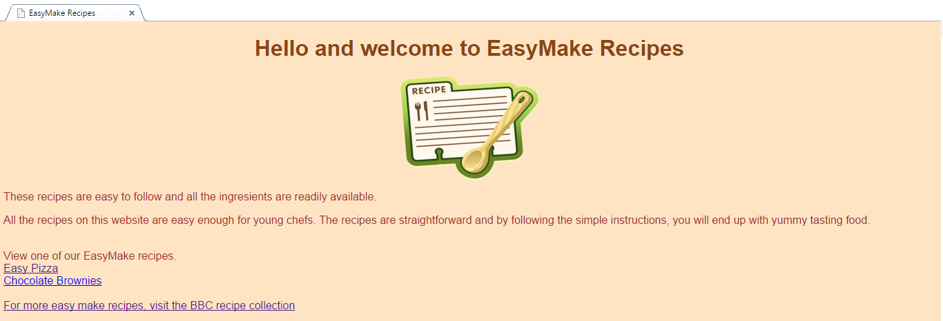

Hyperlinks to recipe pages and external link to BBC site

H1 heading

bulleted list of ingredients

H3

headings

numbered list of instructions

H1 heading

hyperlink to home page

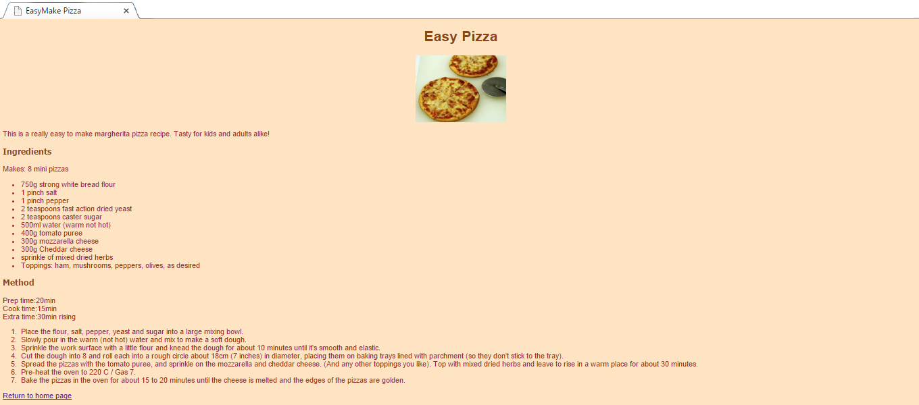

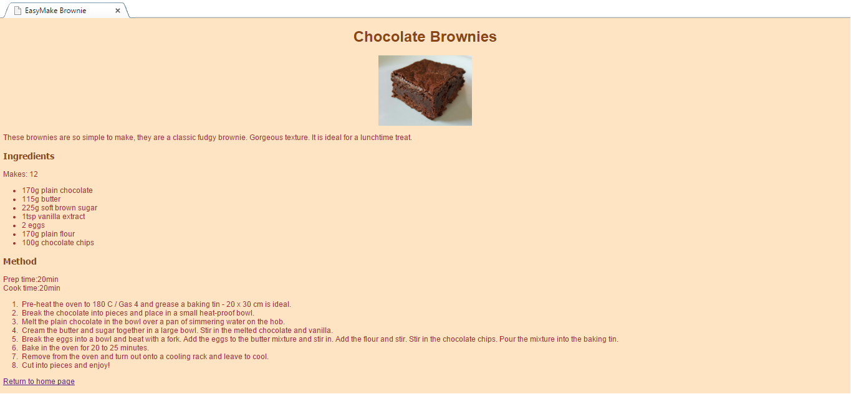

bulleted list of ingredients

H3

headings

numbered list of instructions

H1 heading

hyperlink to home page

**Exercise 4(2): Creating a Website**

You have been asked to create the DinoSite website. The **wireframes** below show the planned layout of the site.

|  |  |
| --- | --- |
| dinosaur.jpg  tyran.jpg  steg.jpg  diplod.jpg |  |
|  |  |
|  |  |

**Task 1: Site Structure**

Use the space below to draw the navigational structure of the DinoSite website.

|  |
| --- |
|  |

The layout of the site should be controlled using CSS and the same internal stylesheet should be applied to each page on the site.

|  |  |
| --- | --- |
| **Body Element**   * The background colour of the page should be black * The main text should be white * The font should be Tahoma size 12 * Text should be left aligned | **H1 Element**   * Font should be Verdana size 40pt * Text should be centred and bold * Text should be white in colour |
|  |  |
| **Anchor Element**   * Link colour should be white * A visited link should be yellow * Hover colour should be cyan | **Dinosaur Class**   * Background colour should be cyan |

**Task 2: CSS selectors**

Create CSS selectors for each element and class listed above.

|  |  |
| --- | --- |
| Body Element | |
|  | |
|  | |
| H1 Element | |
|  | |
|  | |
| Anchor Element | |
| Link | a:link { color: } |
| Visited |  |
| Hover |  |
| *Note: these are 3 separate CSS selectors that must be listed in stylesheet in the sequence stated above.* | |
| Dinosaur Class *(this will only be applied to the tags used to create the home page links)* | |
|  | |

**Task 3: HTML**

Copy the folder called ‘Exercise4(2)’. This folder contains all of the files needed to build the site.

Add the HTML tags needed to create the DinoSite website. Remember that the dinosaur class should only be applied to the tags needed to create the home page links.

**Task 4: CSS**

Add the internal stylesheet to the head section of each page to control how the content is displayed.

**Task 5: More Dinosaurs**

The DinoSite website is to be extended to include details of two more dinosaurs: *pterodactyl* and *allosaurus*.

Like the other pages on the site, these new pages should:

* provide basic details about the dinosaurs
* include an image of the dinosaur
* have a link to the home page

In addition, the page about *pterodactyls* should link to an external site which provides more details about them.

The layout of each new page should be consistent with the layout of the other dinosaur pages. Use the space below to create a **wireframe** for the *pterodactyl* page.

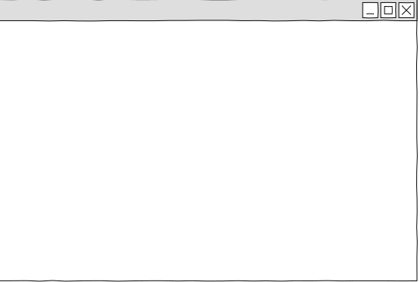

Research these two dinosaurs and then create new pages for the DinoSite. To ensure a consistent appearance, remember to include the same CSS selectors and class that were used on other pages of the site.